Learner: Date:
(3:K5,3:K7, 3:K10, 3:K11, 3:K12)

Task 1
Identify the drawing type and explain what each would be used for.
[assembly drawing – circuit diagram - isometric - third angle projection – block diagram – wiring diagram – general arrangement diagram – fluid power diagram]

Drawing type | Used for
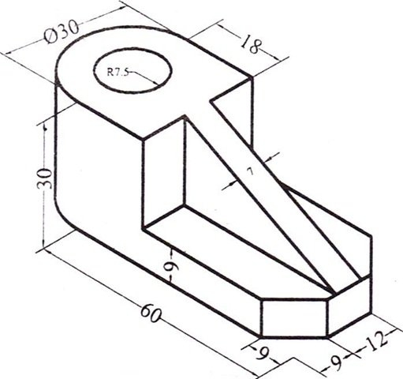
Type:
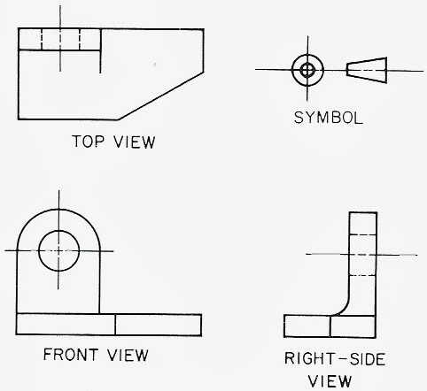
Type:

Drawing type | Used for
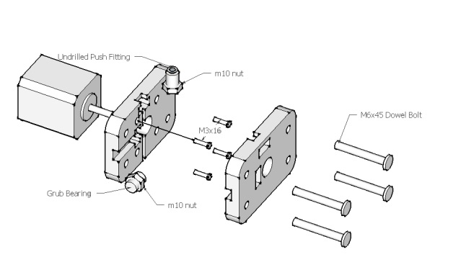
Type:
Type:
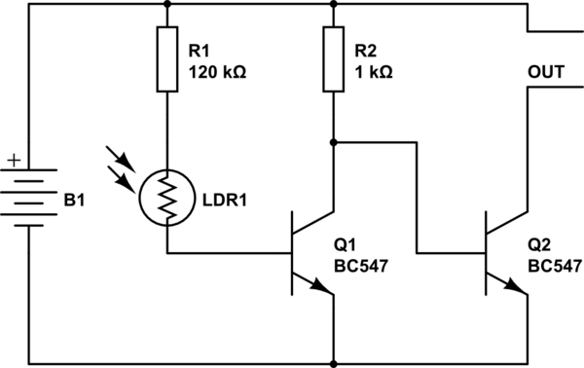

Type:

Drawing type | Used for
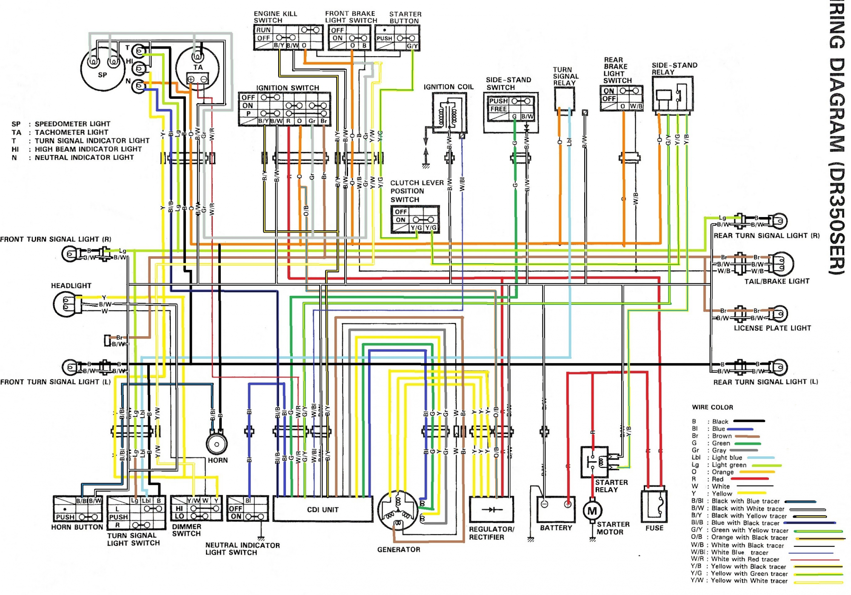
Type:
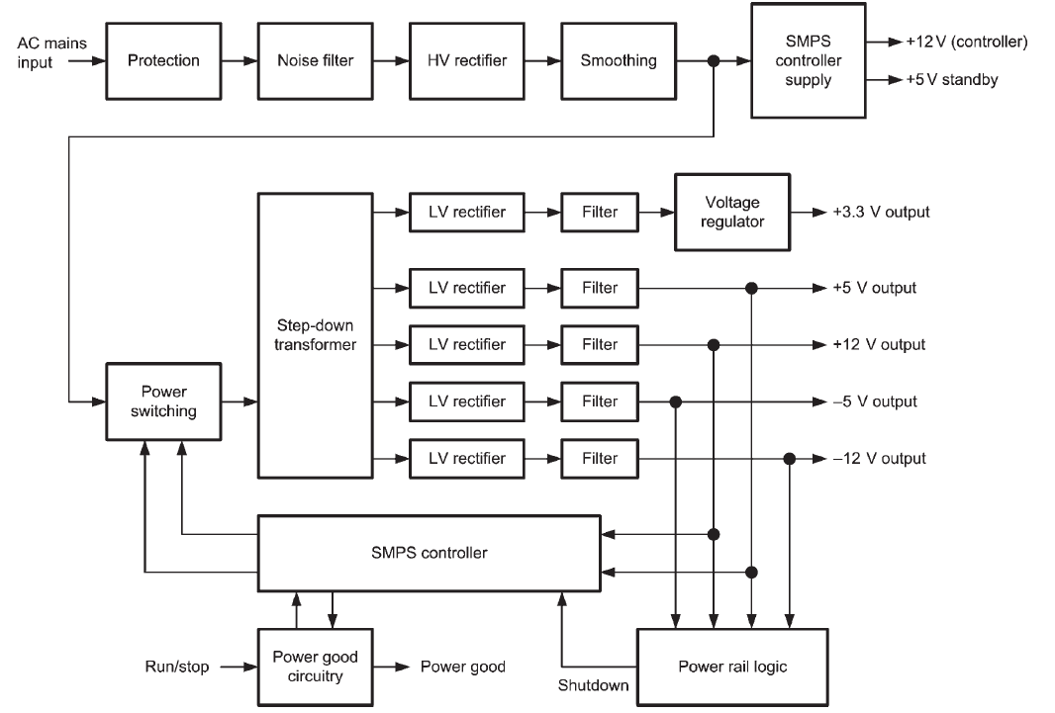
Type:
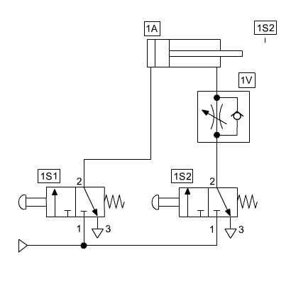
Type:

Task 2
For each of the situations given below, state what the additional information would be used for.

Situation 1: Tap/drill chart
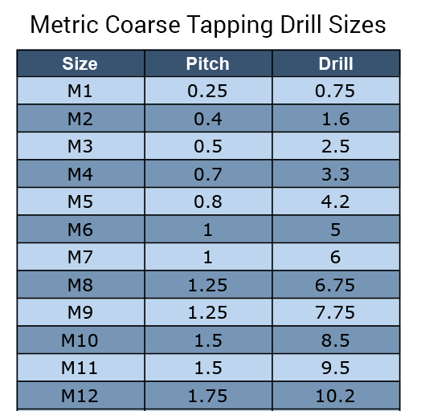
What would this information be used for?
________________________________________________________________________________________________________________________________________________________________________________________________________________________________________________

Situation 2: Bend allowance equation

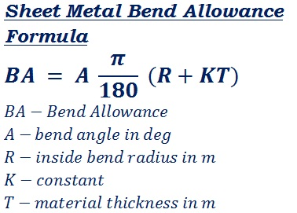
What would this information be used for?
___________________________________________________________________________________________________________________________________________________________________________________________________________________________________________

Task 3
Why might technical information be presented in different ways as shown on the previous pages?

______________________________________________________________________________________________________________________________________________________________________________________________________________________________
Task 4
Describe each of the following forms of communication and tick the appropriate box for the level of detail they should include.

A: Sketch
____________________________________________________________________________________________________________________________________________________
basic detail moderate detail thorough detail

B: Test/inspection reports
____________________________________________________________________________________________________________________________________________________
basic detail moderate detail thorough detail

C: Work planning document
____________________________________________________________________________________________________________________________________________________
basic detail moderate detail thorough detail

Task 5
Why is it important that sketches are of a suitable size and use appropriate drawing conventions?

______________________________________________________________________________________________________________________________________________________________________________________________________________________________

Task 6
Why is it important to use a fixed common reference point (datum) when dimensioning a drawing? See the image below as an example

__________________________________________________________________________________________________________________________________________________________________________________________________________________________________________________________________________________________________________________________________________________________________________________

